All 4 days informations date and session wise…………

_______________________________ Day 01 : 08 - 01 - 2025

____________________________

Machine Lerning

Supervised Learning

Unsupervised Learning

Reinforcement Learning

Supervised => Labled Data

Unsupervised => Unlabled Data

Reinforcement Learning => Environment , Agent , Action , Reward

--------------------------------------------------------------------------------------

Supervised Learning

1). Classification => Numerical Data Ex......Cat , Dog <Specifying>

2). Regrations => Continues Valuies ......... Ex:- Temprature <based on numerical data>

Unsupervised Learning

1). Clustring => Group The Data

2). Assosiation => Relation between two data points.

=>Assosiate with each other

Reinforcement Learning

=> Work flow of ML

Data -> Data Pre Proccesing -> Data Analysis -> Train Test Split -> XGboost Regressor -> Evaluated

-------------------------------------------------------------------------------------------------------------

=> Data Pre Proccesing

Missing values

- Delations

- And droping

Test Traiened

Data Standardedlizations

Lable Encodeings

Fetured Exteractions

Handle InBalanced Data

------------------------------------------------------------------------------------------------------------------

=> Data Analysis Topics

Simple Random Sempling

Systematic Sempling

Staratified Random Sempling

Cluster Sempling

------------------------------------------------------------------------------------------------------------------

=> Central Tendancy "Value That Sumerized The Data."

1. Mean

2. Median

3. Mode

------------------------------------------------------------------------------------------------------------------

Quantiles "Cut The data As The Equaly Size Like 50 , 25 , 25 "

------------------------------------------------------------------------------------------------------------------

Correlation " Relation Between Two Variable"

positive -> house & number of room

negative -> house & crime rate of areas

------------------------------------------------------------------------------------------------------------------

Hypothesis "Assumtion of based on observation of an experiments."

1. Null Hypothesis ( H0 ) <RAW ASSUMPTIONS>

2. Alternative Hypothesis ( Ha ) <ASSUMPTION AFTER STUDY>

------------------------------------------------------------------------------------------------------------------

Normal Distribution also known as Gaussion Disribution

"Arrangement of dataset In which most of the data points lie to middle of the range.... "

------------------------------------------------------------------------------------------------------------------

Skewness

"Distribution curved appear distored or skewed either to the left or to the right..."

Statical distribution .......

------------------------------------------------------------------------------------------------------------------

Types of kurtosis

1.Platykurtics

2.Mesokurtosis

3.Leptokurtosis

Overfitting and Underfitting....

Bias - Variance Tradeoff....

tecjhnique to have been bias variable trade off

1.ggod model selection

2.reguarlization

3.dimentionaly redusions

Loss Function

Type :-

1. cross entropy

2. Squared error

3. kl divergence

accuracy rate / scoure ....

===================================================================

Confusion Matrix

--> Evalueate the perfomance of a claasification model.

=================================================

Precision

F1 Scoure

Confusion Matrix

Mean Square Error

R Square Error

Model Selections

===================== 10.30 to 12.30 ==================

Model Selections

--------------------------------------

after that we Learned a particullarly numpl may be its complete numpy from the chatgpt<task write a full numpy and explain complete numpy>

____________________________________________________________________

Model Selections

Model selected based on a

1). Type Of Data Available

a. Image And Videos ( CNN )

b. TExt Data Or SpeechnData ( RNN )

c. Numerical Data ( SVM ) , Logical regrations

2). Based On the task we need to cary out

a. Calasification Task ( SVM )

b. Regration Task ( Linear Regrations )

c. Clustring Task ( K-Mean Clustring )

lib - 1 - Numpy

# Introduction Of Numpy

lib - 2 - Pandas

# Introduction Of Pandas <learned skelearn>

=> Give Pandas Tutorial In Python

# Introduction Of Skelearn <from pandas lib>

_______________________________

lib - 3 - Mateplotelib

# Introductions Of Matplotelib Library

if you want to describe usage numpy pandas mateplotelib in one one line what was be that

Sine

Cosine

# Methods of Missisng Values

1. Imputations

2. Droppings

# Data Standaredizations In Python ( sklearn )

=> Train and Test In (sklearn) ==== "Canser dataset"

=> Standard scaler formate converting

# Lable Encoding ( Using Breast Canser Dataset )

=> Lable convert into numerical values .................

=> count ( )

=> head ( )

=> LableEncoder ( )

=> fit_transform ( )

=> values_count ( )

=>

__________________________ After 1.00 To 3.00 _________________________________________

download one dataset ( Bengaluru House price data )

https://www.kaggle.com/datasets/amitabhajoy/bengaluru-house-price-data

____________________________________=======================____________________________________________

Day : - 09 - 01 - 2025

Supervised Learning :-

1). Classification

2). Regrations

2).Regression

1.Simple Linear Regression

2.Multiple Linear Regression

3.Polynomial Regressions

4.Logistic Regrassions.

what if there are more than 2 variable in Multiple Linear Regression

_____________ Loss Function _____________

____________ Model Optimizations _____________

_____________ Gradient Decent __________________

_____________ Regression Models __________________

=> What Is Polynomial Regrassion

=> Mean Square Error

=> Polynomial Features

=> Logistic Regressions

__________________________________________====== 10.40 to 12.30 ====== _______________________________________

=> Classification Algorithams

=> Support Vectore Machine

1. Supervised Learning Model

2. Both Classification And Regressions

3. Hyperplane

4. Support Vector

=> Support Vector Machine Classifier

SVM in 2 - Daimentions

SVM in 3 - Daimentions

=> Optimaization For Maximum Values in SVM

=> Maximum Margin Without Overfitting

=> SVM Kernals

1. Linear

2. Polynomial

3. Radial Basis Function (RBF) or Gaussian Kernel

4. Sigmoid Kernel

Linear Kernel: ( K(x, y) = x * y )

Polynomial Kernel: ( K(x, y) = (x * y + c)^d )

RBF Kernel: ( K(x, y) = \exp( -{||x - y||^2}{2\a^2} ) )

Sigmoid Kernel: ( K(x, y) = \tanh(a x * y + c) )

=>Hinge Loss

1. Miss Calssifications

2. Correct Classifications

=> Gradient Decent

=> SVM Classifier

Iris Dataset Using this

=> Logistic Regression

1. Supervised Learning Model

2. Calssification Model

3. Best For Binary Classification Problem

4. User Sigmoid Functions

=> Sigmoid Or Logit Function

=> Implimentations

=> Introduction To Naive Bayes

P ( C / X ) = P ( X / C ) P ( C ) / P ( X )

P ( C / X ) = Posterior Probebility

P ( X / C ) = Likelihood

P ( C ) = Prior Probability

P ( X ) = Evidence

_________________________________========== 1 : 00 To 3 : 00 ============___________________________

=> Naive Bayes Examples

=> Decision Tree Approch

1). Information Gain

=> Entropy

=> Weighted Average Entropy

2). Gini Index

=> Gini ( Splite )

=> Iris Dataset Confusion Matrix

=> For Decision Tree Code With DataSet (Iris Dataset)

____________________________________=======================____________________________________________

Day 03 :- 10 - 01 - 2025

_________________________ 8:00 TO 10:30 _________________________________

=> Unsupervised Learning

1). Clustring Algoritham

-> K-Mean Clustring

-> Hierarchical Clustering

-> DBSCAN ( Density-Based Spatial Clustering Of Applications With Noise )

2).Dimensionality Reduction Algoritham

-> Principal Component Analysis ( PCA )

3).Association Rule Learning

-> Apriori Algoritham

=> Applications Of Clustring

1). K-Mean Clustering Algoritham

=> K - Mean Algoritham With Dataset Example

____________________________________________________________

What Is Hirechical Clustring ?

What is a Agglomerative Clustring ?

How Agglomerative Clustring works ?

What is a Divisive Clustring ?

How Divisive Clustring works ?

What Is Dendrogram ?

Ward Methods

__________________________________ 10.30 to 12.30 _______________________________________

DBSCAN

DBSCAN Algoritham:-

=>

PCA ( Principle Component Analysis )

How PCA Works ?

=>

____________________1.30 to 3.00 ______________________

Apriori Algoritham

Assosiation Rule Learning.....

Reinfocement Algoritham

Q-Learning Algoritham

________________________________ Day :- 04 :- 11 - 01 - 2025 ________________________________

_____________________________8.30 To 10.20__________________________________

Version Control Tool

**A Version Control Tool, Also Known As A Version Control System (VCS) Or Source Code Management (SCM) System**

**Helps Track and Manage Changes To Files And Code In A Collaborative Development Environment**

=> Git ( Local Git )

=> Git Hub ( Cloud Base Repositiory Online )

Download A Git

Open Command Promt

---> git -v

git version 2.47.1.windows.1

=> Gout Configuration Leval

* System leval
* User leval ( Global )
* Repository leval

=> check config

* git config --system --list
* git config --global --list

=> To Config

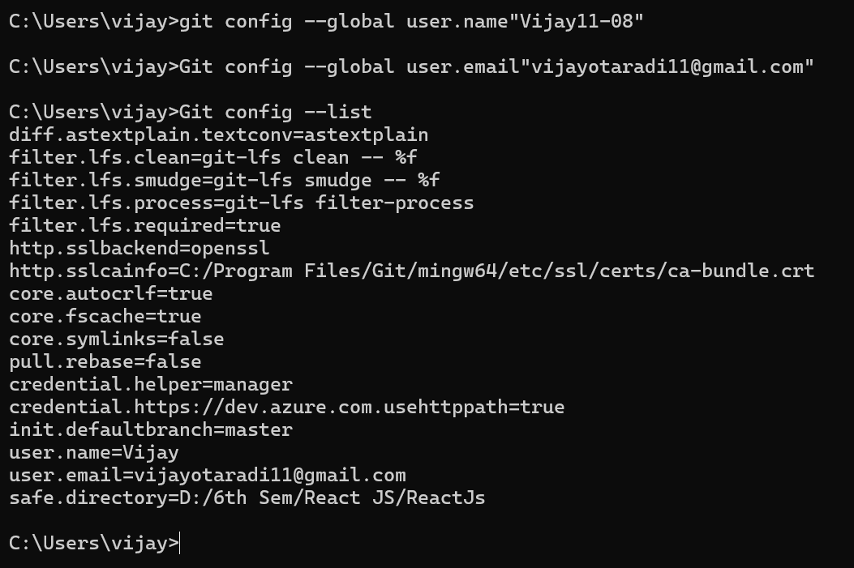

To Check the Configuration files

Goto **C Drive** => **User** => **Vijay** => **gitconifi file**

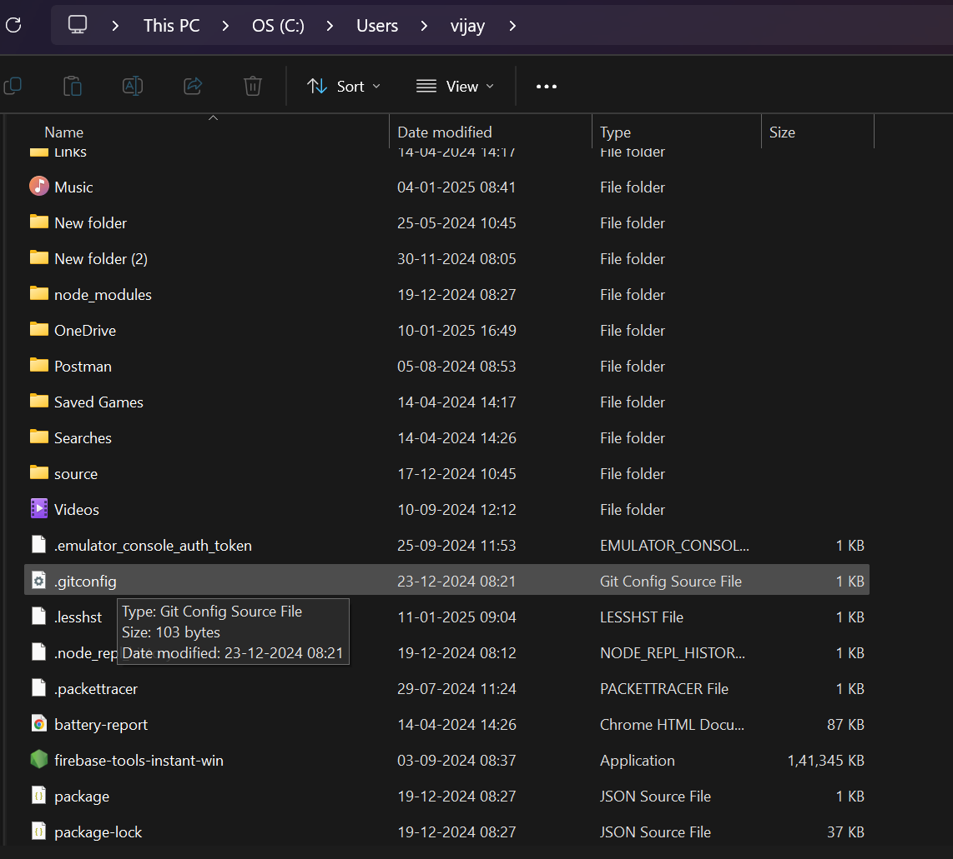

Git Work Folw ➖

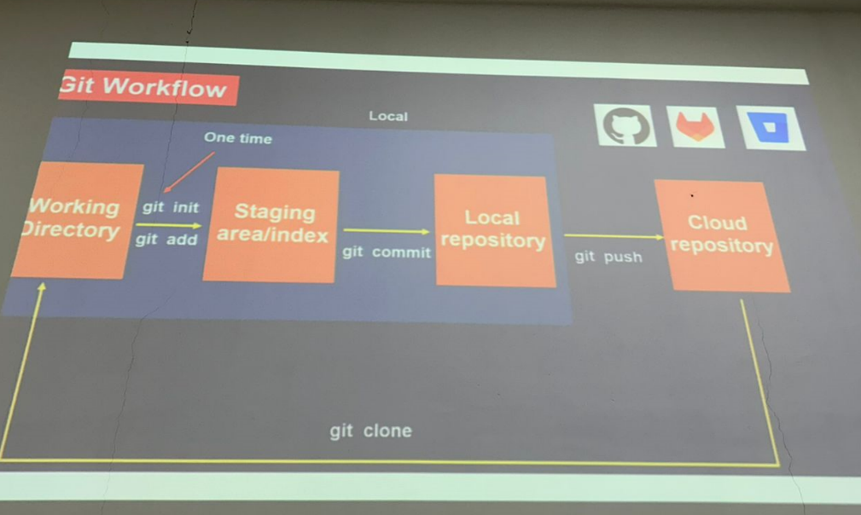

**Git Commands**

* Git status
* Git init
* Git add
* Git commit -m “message”
* Git log

**To Work With Git :-**

* **Create A Folder**
* **Enter Into The Folder Using Command Prompt**
* **Check for status**
* **Git status -> Not because , not initialized**
* **Git init => Create a new hidden folder and make it visible if you want**
* **Open a vs code & Load The folder**
* **Create a file**
* **Check the git status**

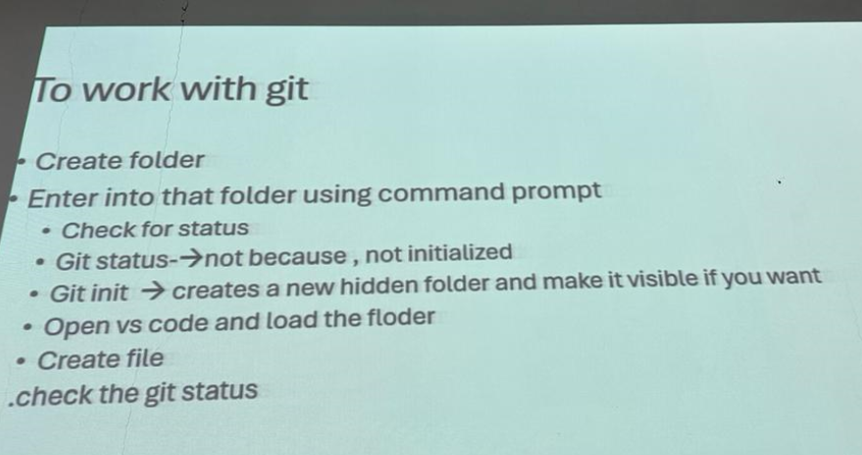

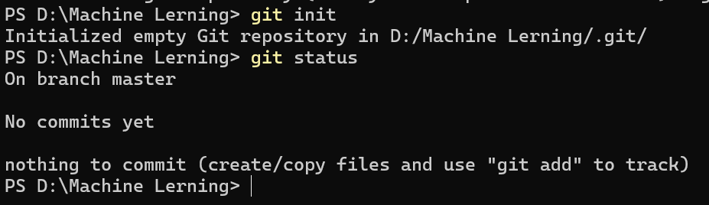

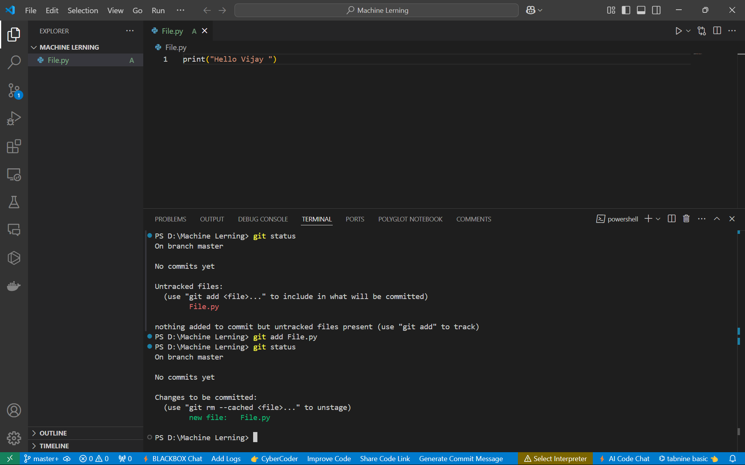

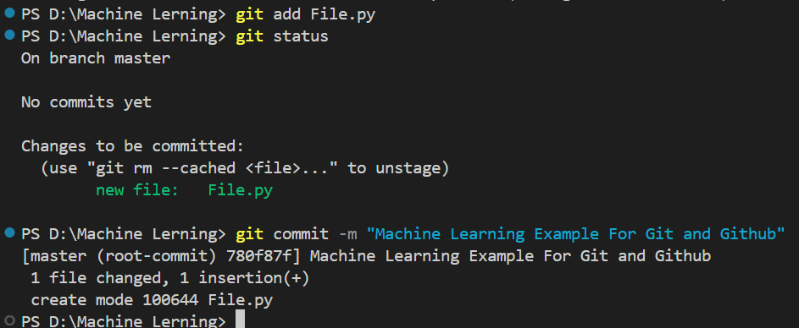

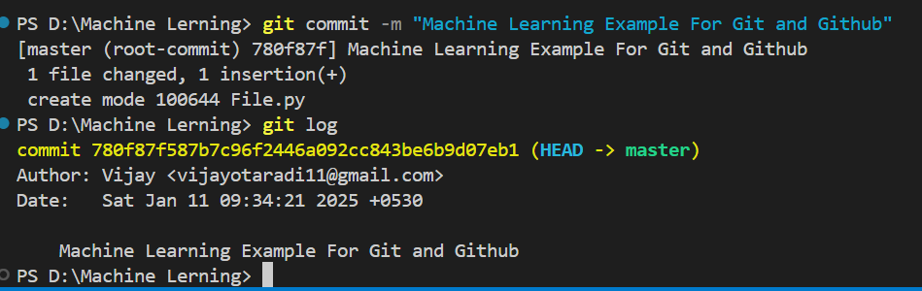

**How to upload project in github**

**Create a repository in github**

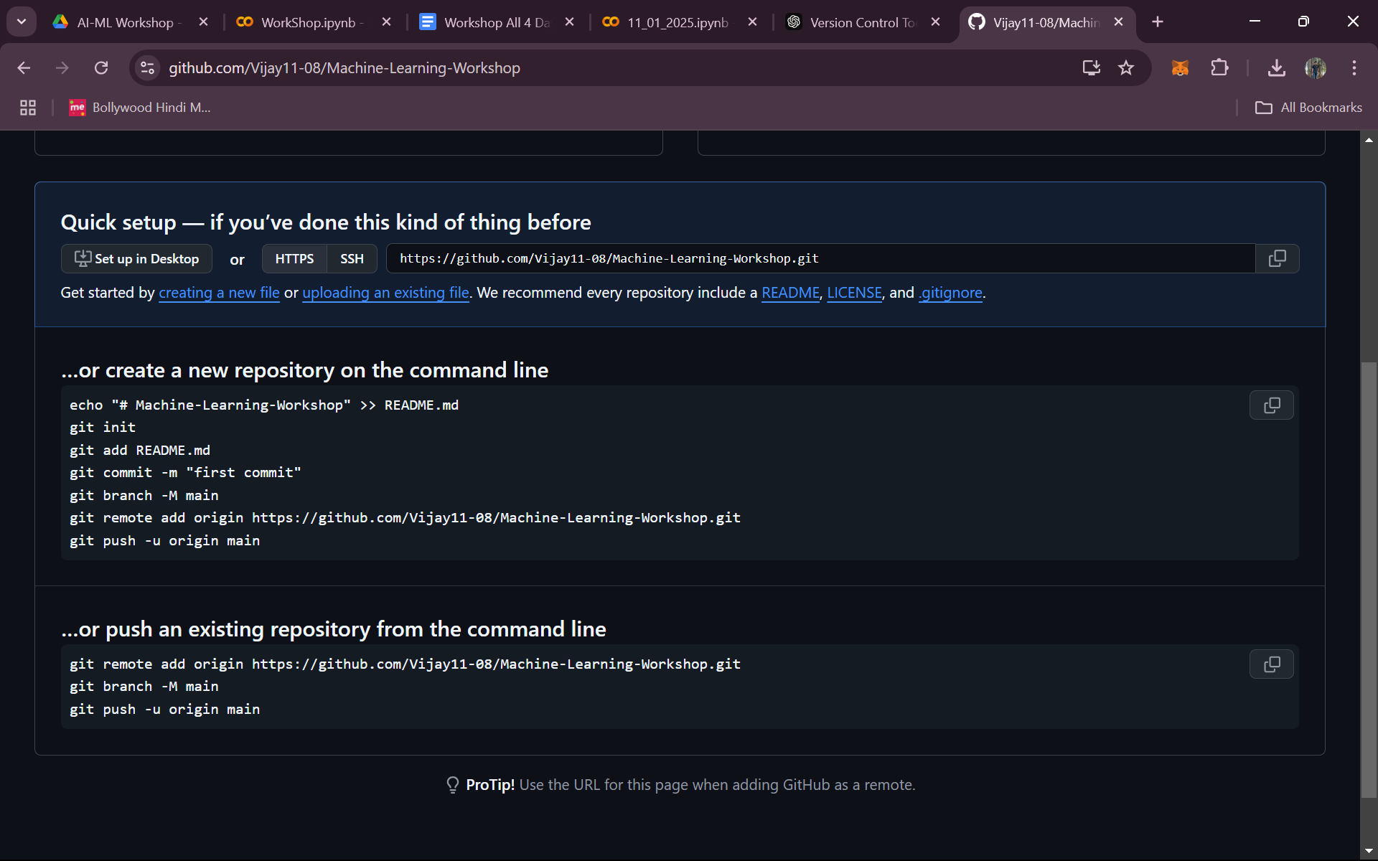

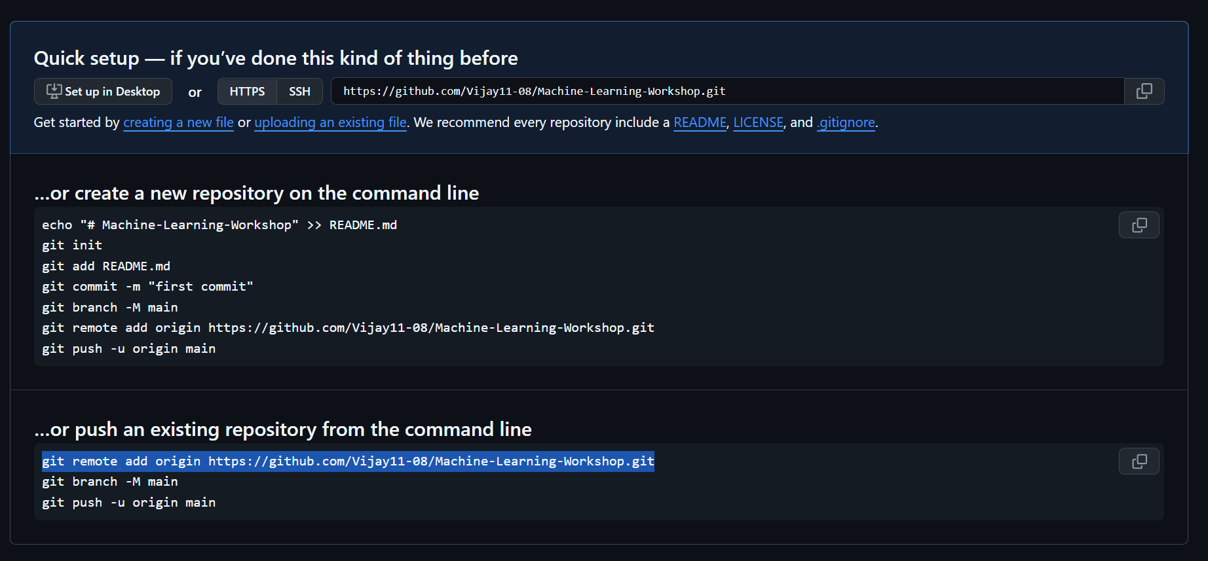

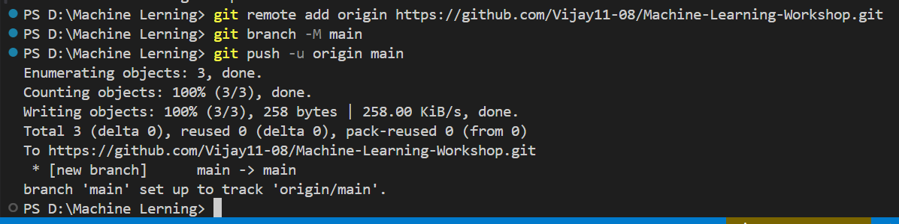

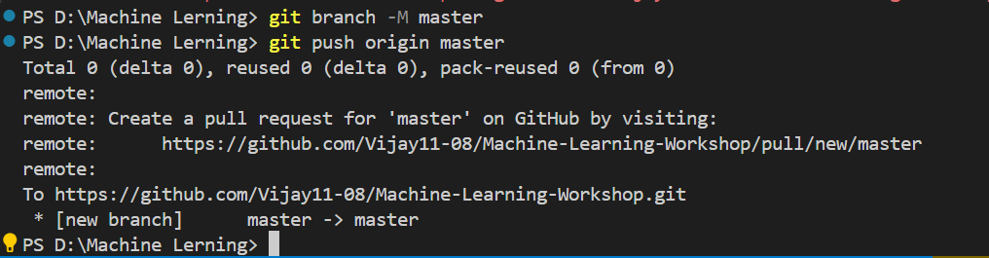

**Git Colne**

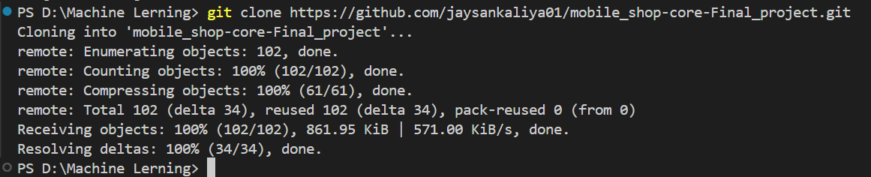

**Git Logs Chaecking**

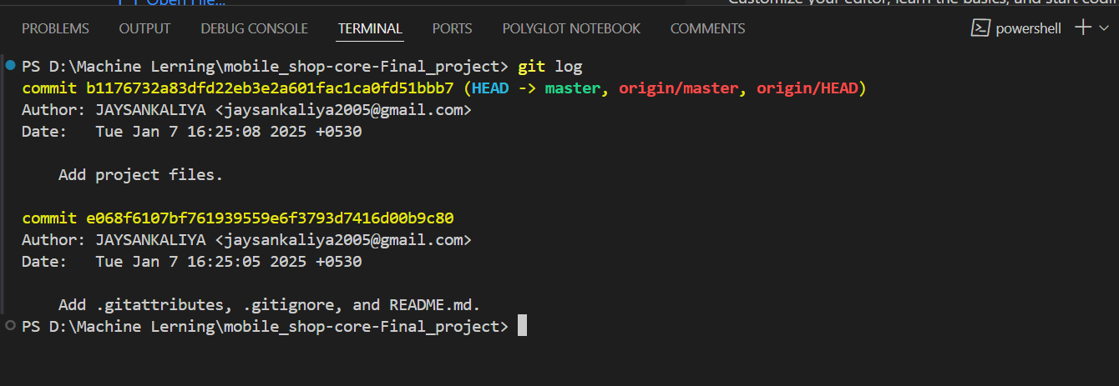

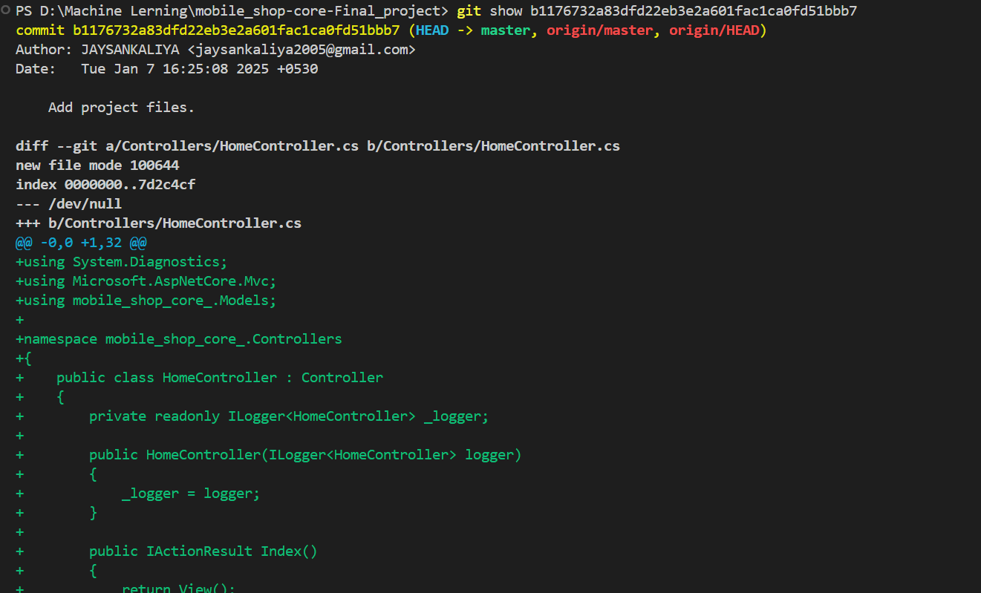

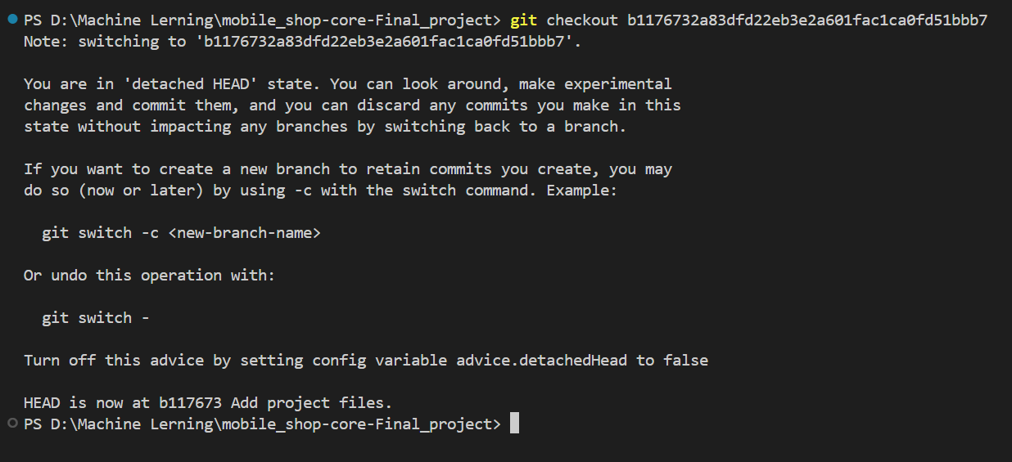

**Introduction of deep learning**

**Neural network**

**How to computer reads an image?**

**How CNN Works?**

**Convolution**

**ReLU Layers**

**Pooling**

**Fully Connected**

**Version Control Tool**

**=> Git ( Local Git )**

**=> Git Hub ( Cloud Base Repositiory Online )**

**Download A Git**

**Open Command Promt**

**---> git -v**

**git version 2.47.1.windows.1**

**Create a github account**

**=> Gout Configuration Leval**

**System leval**

**User leval ( Global )**

**Repository leval**

**=> check config**

**git config --system --list**

**git config --global --list**

**=> To Config**

**git config --global user.name"Vijay11-08"**

**Git config --global user.email"vijayotaradi11@gmail.com"**

**Git config --list**

**To Check the Configuration files**

**Goto C Drive => User => Vijay => gitconifi file**

**Git Workflow**

**Working Directory => Staging Area/Index => Local Repositiory => Cloud Repositiory**

**git init / git add git commit git push**

**Git Commands**

**Git status**

**Git init**

**Git add**

**Git commit -m “message”**

**Git log**

**Git login**

**Create Repo**

**how add file in Repo**

**Git Cloning**

**git show**

**git checkout**

**Introduction of deep learning**

**Neural network**